**Automate Replying to an Email**

We have automated the workflow where a user can reply to a specific type of email.

The workflow steps are outlined below:

**Prerequisites:**

* Google Console Credentials: Client ID and Client Secret
* Gmail API enabled

**Step-by-Step Process**

**Step-1: Create a new Workflow**

You need to select **Create Workflow** from the top left of the canvas.

A blank canvas will open.

**Step-2: Select the first node to filter email**

When you click on the **+** icon on canvas, n8n will prompt you with **What triggers this workflow?** At the top of the dialog, there is a search bar where you can type any keyword to filter the available options.

Type ‘gmail’ and select **Gmail** and then select **Get Many messages**.

The following configuration window will open. If you already have credential for Gmail account, select it from the drop-down, otherwise select **Create new credential**.

New window to create credentials will open:

If you don’t have Client ID and Client Secret in Google Cloud and Gmail API is not enabled in the services, then go to <https://console.cloud.google.com/>. Following window will appear.

* Click on **Select a project**.

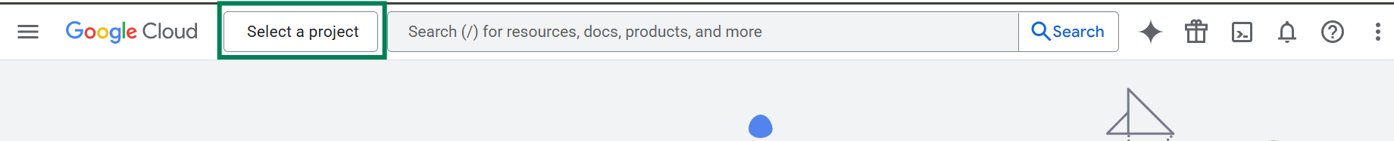

* Click on **New Project**

* Fill in the required information and click on **Create** button.

A billing account will be required to proceed with the services.

* Check whether the correct project is selected or not.

* Select **API & Services**.

* Go to **Enabled APIs & Services**.

* Search ‘gmail’. Select **Gmail API** from the list.

* Check if **Gmail API** is enabled or not.

* If API is disabled, click on **Enable** button to enable it.

* Go to **Credentials** now.

* Click on **Create Credentials**.

* Select **OAuth client ID** from the list.

* Fill in the information as follows:

* Copy following URL from N8N window and add it here. Click on **Save** button.

* Once the credentials are created store it in a secure location. You can’t retrieve the **Client Secret** later from the console.

You have successfully created the credential for Gmail account. Now, go to N8N again and fill in the credential information.

Click on **Sign in with Google**. Select the google account.

Click **Continue**.

Check **Select all** and click on **Continue**.

If the connectivity is established, you will see following prompt.

You will now see **Account connected** on the top of the credential screen.

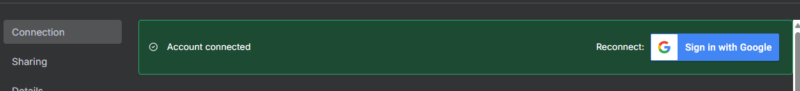

Click on cross button to exit the credential screen and get back to the **Get many messages** window.

Follow these steps for the configuration:

* Resource: Select **Event**
* Operation: Select **Get Many**
* Calendar: Select your calendar account from the dropdown
* Return All: Keep disabled
* Limit: Set limit
* After: Enter the start time *(Default: {{ $now }})* to get events from that date/time onward.
* Before: Enter end time to get events up to that time.
* Options(optional):
  + Order By: Select **Start Time** to sort events chronologically
  + Query: Enter any search term to filter events containing that keyword

You can add more options by clicking **Add option**

You can rename this step with a meaningful title (as example: Emails to Reply) to make it easier to understand the purpose of the step.



You can click on **Execute step** if you want to check the output from this step. If this is executed, you can use this output as input for the next step to execute and test that as well.

If you want to know more details about a particular node, click on **Docs**.

Click on **Back to canvas** to exit from this window.

Click on **Save** or press **Ctrl+S** after adding any new component or making changes, otherwise it will not be saved automatically.



**Step-3: Get the email details needed for a reply**

Click on the + button to add next step.

For the next node, type ‘code’ and select **Code.**

The following configuration window will open.

Follow these steps for the configuration:

* Mode: Select **Run Once for All Items**
* Language: Select **JavaScript**
* JavaScript Code: Enter the following code in the editor to get data from previous step and pass data to next step:

**Step-4: Set up the reply email**

For next node, select **Reply to a message**.

The following configuration panel will open:

Follow these steps for the configuration:

* Credentials to connect with: Select **Gmail Account** from the drop-down menu
* Resource: Select **Message**
* Operation: Select **Reply**
* Message ID: Drag it from input panel or type *{{ $node['Get Email Data'].json.messageId }}*  
    
  *A screenshot of a computer

  AI-generated content may be incorrect.*
* Email Type: Select **HTML**
* Message: Write message following html syntax  
    
  *<b>Hi </b>*

*<br><br>Acknowledged.*

Rest of the fields should be kept unchanged.

**Execution:**

Now, if you click any of these, the complete workflow will be executed.

